1. **Addition of two Numbers**

**Program**

void main(){ **Output Screen**

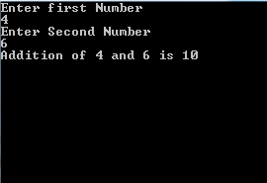 int n,n2,sum;

clrscr();

printf("Enter first Number");

scanf("%d",&n);

printf("Enter Second Number");

scanf("%d",&n2);

sum = n+n2;

printf("Addition of %d and %d is %d",n,n2,sum);

getch();

}

1. **Find Whether Number is Odd or Even** **Program** **Output Screens**

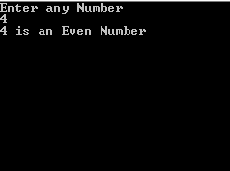void main(){

int n,res;

clrscr();

printf("Enter any Number ");

scanf("%d",&n);

res=n%2;

if(res==0)

printf("%d is an Even Number",n);

else

printf("%d is an Odd Number",n);

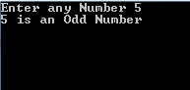getch();

}

1. **To Find average of three integers**

**Program**

void main(){

int a,b,c,average;

clrscr();

printf("To find Average of three Numbers");

printf("\nEnter the three Numbers");

scanf("%d %d %d",&a,&b,&c);

average=(a+b+c)/3;

printf("The Average is %d",average);

getch();

}

1. **To Find the sum of first and last digit of a 4-digit number**

**Program** **Output Screen**

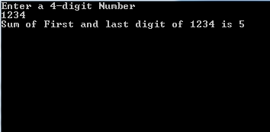void main(){

int x,l,r,sum=0,n;

clrscr();

printf("Enter a 4-digit Number");

scanf("%d",&x); n=x;

while(x!=0){

r=x%10;

x=x/10;

if(l==1 || l==4)

sum=sum+r;

l--;

}

printf("Sum of First and last digit of %d is %d",n,sum);

}

1. **To Reverse a 5-digit Number**

**Program** **Output Screen**

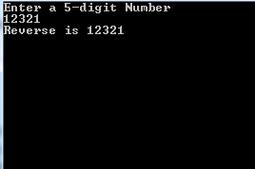void main(){

int x,r;

double rev=0;

clrscr();

printf("Enter a 5-digit Number");

scanf("%d",&x);

while(x>0){

r=x%10;

x=x/10;

rev=(rev*10)+r;

}

printf("Reverse is %.0f",rev);

getch();

}

1. **To Show the use of Escape Sequence**

**Program** **Output Screen**

void main(){

clrscr();

printf("A \nB is now in a New Line.\n");

printf("A \t B is now displayed after a Tab.");

printf("\n Use of new line and carriage return\r");

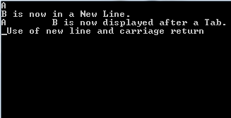 getch();

}

1. 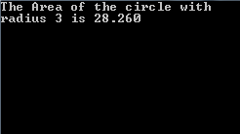**To Find the Area of a circle with radius 3**  **Program** **Output Screen**

void main(){

double r,area;

r=3;

clrscr();

area=(3.14)*r*r;

printf("The Area of the circle with \nradius 3 is %.3f",area);

getch();

}

1. **To Swap Two Numbers using Third Variable**

**Program Output Screen**

void main(){

int a,b,c;

clrscr();

printf("Swapping using a third variable.");

printf("\nEnter Two Numbers\n");

scanf("%d %d",&a,&b);

printf("Before Swapping. \n a and b is %d %d",a,b);

c=a;

a=b;

b=c;

printf("\nAfter Swapping. \n a and b is %d %d",a,b);

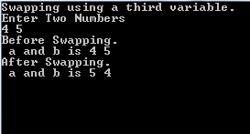 getch();

}

1. **To Swap Two Numbers without using Third Variable**

**Program** **Output Screen**

void main(){

int a,b,c;

clrscr();

printf("Swapping using a third variable.");

printf("\nEnter Two Numbers\n");

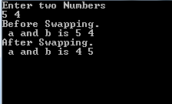 scanf("%d %d",&a,&b);

printf("Before Swapping.

\n a and b is %d %d",a,b);

a=a+b;

b=a-b;

a=a-b

printf("\nAfter Swapping. \n a and b is %d %d",a,b);

getch();

}

1. **To Check if an integer is positive or negative**

**Program** **Output Screen**

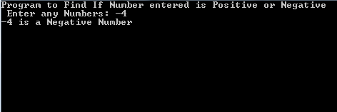void main(){

int a;

clrscr();

printf("Program to Find If Number entered is Positive or Negative\n Enter any Numbers: ");

scanf("%d",&a);

if(a==0)

printf("%d is Zero and is Neither Positive or Negative Number");

else if(a<0)

printf("%d is a Negative Number",a);

else

printf("%d is a Positive Number",a);

getch();

}

1. **To Check if an employee gets a bonus**  **Program** **Output Screen**

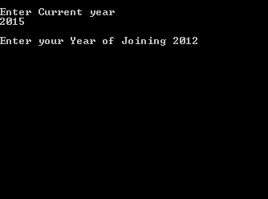void main(){

int year,yoj,bonus;

clrscr();

printf("\nEnter Current year \n");

scanf("%d",&year);

printf("\nEnter your Year of Joining ");

scanf("%d",&yoj);

if((year-yoj)>3){

bonus=2500;

printf("You Received a bonus of:%d",bonus);

}

else

printf("You Received no bonus.");

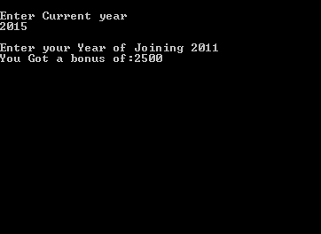 getch();

}

1. **To Calculate net salary**  **Program** **Output Screen**

void main(){

float da,hra,pf,ns,bs;

clrscr();

printf("Calculate the Net Salary\n");

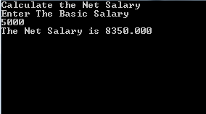 printf("Enter The Basic Salary ");

scanf("%f",&bs);

da=bs*0.45;

hra=bs*0.3;

pf=bs*0.08;

ns=bs+hra+da-pf;

printf("The Net Salary is %.3f",ns);

getch();

}

1. **To Calculate Total Expenses**  **Program** **Output Screen**

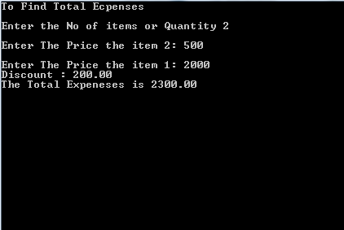void main(){

float price,total_exp=0,discount;

float total_dis=0;

int quantity;

clrscr();

printf("To Find Total Expenses\n");

printf("Enter the No of items or Quantity ");

scanf("%d",&quantity);

while(quantity>0){

printf("\nEnter The Price the item %d: ",quantity);

scanf("%f",&price);

if(price>1000){

discount=price*0.1;

total_dis+=discount;

}

else{

discount=0;

total_dis+=discount;

}

total_exp+=price-discount; quantity--;

}

printf("Discount : %.2f \nThe Total Expeneses is %.2f",total_dis,total_exp);

getch();

}

1. **WAP to Find Net Salary, Gross Salary and Display pay slip**

**Program**

void main(){

float da,hra,pf,ns,gs,bs,bonus;

int des_code,emp_no=1;

clrscr();

printf("To Display pay slip\n");

printf("Enter The Basic Salary\n ");

scanf("%f",&bs);

printf("Enter The Designation Code\n");

scanf("%d",&des_code);

da=bs*0.5;

hra=bs*0.4;

pf=bs*0.1;

if(des_code==101)

bonus=2000;

else

bonus=1550;

ns=bs+hra+da+bonus-pf;

gs=ns+pf;

printf("The Pay Slip is Given Below\n\n");

printf("Emp no\tBasic Pay\tDA\tHRA\tPF\t Bonus\t G.S\t Net Salary\n\n");

printf("%d\t%.0f\t\t%.0f \t%.0f\t %.0f\t %.0f\t %.0f \t %.0f",emp_no,bs,da,hra,pf,bonus,gs,ns);

getch();

}

**Output Screen**

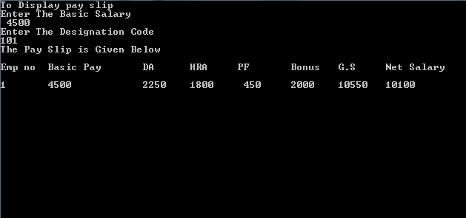

1. **WAP to Check if driver is insured or not**

**Program** **Output Screen**

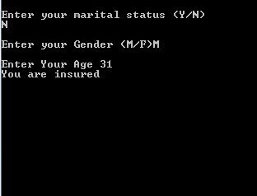void main(){

char m,s;

int age;

clrscr();

printf("\nEnter your marital status (Y/N)\n");

scanf("%c",&m);

if((m=='Y')||(m=='y')){

printf("You are insured");

}

else if((m=='N')||(m=='n')){

printf("\nEnter your Gender (M/F)");

scanf("%s",&s);

printf("\nEnter Your Age ");

scanf("%d",&age);

if((s=='M')||(s=='m')){

if(age>30)

printf("You are insured");

else

printf("You are Not insured!");

}else{

if(age>25)

printf("You are insured");

else

printf("You are Not insured!");

}

}else

printf("Sorry You are not Insured.");

getch();

}

1. **WAP to Find Average of Max n number**

**Program** **Output Screen**

void main(){

int no,max,count,sum=0,div,average;

clrscr();

printf("To find Average of Max n Numbers");

printf("\nEnter the Max N or Max limit");

scanf("%d",&max);

div=max;

for(count=1;count<=max;count++){

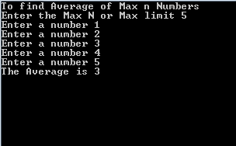 printf("Enter a number");

scanf("%d",&no);

if(no>0)

sum+=no;

else

div--;

}

average=sum/div;

printf("The Average is %d",average);

getch();

}

1. **WAP to Find Product of Four Numbers**

**Program** **Output Screen**

void main(){

int no,i=1,prod=1; clrscr();

printf("To find Product of 4 Numbers\n");

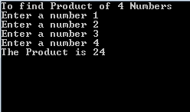 while(i<=4){

printf("Enter a number ");

scanf("%d",&no);

if(no!=0){

prod*=no;

i++;

}

}

printf("The Product is %d",prod);

getch();

}

1. **WAP to Find Factorial of a Number  
   Program** **Output Screen**

void main(){

int no,fact=1,i; clrscr();

printf("To find Factorial of a Number");

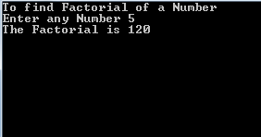 printf("\nEnter any Number");

scanf("%d",&no);

for(i=1;i<=no;i++)

fact*=i;

printf("The Factorial is %d",fact);

getch(); }

1. **WAP to Print Series : 1 - 1/22 +1/32 -1/42 +1/52...... Program** **Output Screen**

void main(){

int n,s=1,nxt,f=0,sum=0,avg,i=0;

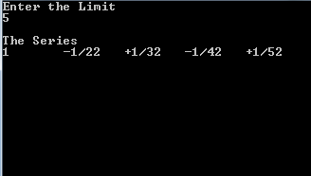 clrscr();

printf("Enter the Limit");

scanf("%d",&n);

printf("Fibonacci Series:\n");

printf("%d",f);

while(i<n-1){

printf("\t%d",s);

sum+=s;

nxt=f+s;

f=s;

s=nxt;

i++;

}

avg=sum/n;

printf("\nSum of the Series is %d \nAverage of the Series is %d",sum,avg);

getch();

}

1. **WAP to count the number of digits Program** **Output Screen**

void main(){

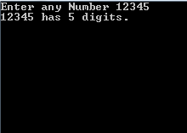 int no,x,count=0;

clrscr();

printf("Enter any Number");

scanf("%d",&no);

x=no;

while(x>0){

x=x/10;

count++;

}

printf("%d has %d digits.",no,count);

getch();

}

1. **WAP to Find if a number is An Armstrong Number Program** **Output Screen**

void main(){

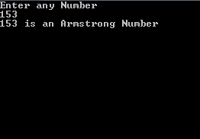 int x,r,sum=0,ref;

clrscr();

printf("Enter any Number");

scanf("%d",&x);

ref=x;

while(x>0){

r=x%10;

x=x/10;

r=r*r*r;

sum+=r;

}

if(sum==ref)

printf("%d is an Armstrong Number",ref);

else

printf("%d is not an Armstrong Number",ref);

getch();

}

1. **WAP to Print Fibonacci Series**

**Program** **Output Screen**

void main(){

int n,s=1,nxt,f=0,sum=0,avg,i=0;

clrscr();

printf("Enter the Limit");

scanf("%d",&n);

printf("Fibonacci Series:\n");

printf("%d",f);

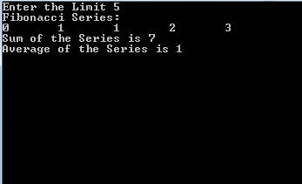 while(i<n-1){

printf("\t%d",s);

sum+=s;

nxt=f+s;

f=s;

s=nxt;

i++;

}

avg=sum/n;

printf("\nSum of the Series is %d \nAverage of the Series is %d",sum,avg);

getch();

}

1. **WAP to Find biggest and smallest NUMBER**

**Program** **Output Screen**

void main(){

int a,b,c;

clrscr();

printf("Program to Find The Biggest and Smallest\n Enter any three Numbers: ");

scanf("%d %d %d",&a,&b,&c);

if(a>b && a>c)

printf("%d is the Biggest",a);

else if(b>c)

printf("%d is the Biggest",b);

else

printf("%d is the Biggest",c);

getch();

}

1. **WAP to Find Value of a Number raised to another number**

**Program**

void main(){

int no,pow,i,prod=1;

clrscr();

printf("To find a Number raised to another Number.");

printf("\nEnter any Number\n");

scanf("%d",&no);

printf("Enter the Number where %d is to be raised to:\n",no);

scanf("%d",&pow);

for(i=1;i<=pow;i++){

prod*=no;

}

printf("%d raised to power of %d is %d",no,pow,prod);

getch();

}

**Output Screen**

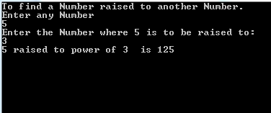

1. **WAP to Print Prime numbers**

**Program** **Output Screen**

void main(){

int n,num,div,p=1;

clrscr();

printf("\n Enter the limit:");

scanf("%d",&num);

printf("Prime numbers till %d are :\n",num);

for(n=2;n<=num;n++){

for(div=2;div<n;div++){

if(n%div==0){

p=0;

break;

}

p=1;

}

if(p){

printf("\t %d",n);

}

}

getch();

}

1. **WAP to check if user input is a digit or not**

**Program** **Output Screen**

#include<stdio.h>

#include<conio.h>

#define ISDIGIT(x) x>=48 && x<=57

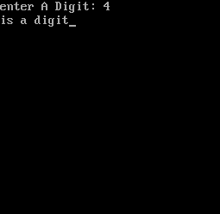

void main(){

char c;

clrscr();

printf("enter A Digit :");

scanf("%c",&c);

if(ISDIGIT(c))

printf("is a digit");

else

printf("This is illegal");

getch();

}

1. **WAP to find Average and Deviation of given numbers**

**Program**

void avg_dev(int a[],int);

void main(){

int nos[100],n,i;

clrscr();

printf("\n Find Average and Deviation \n Enter the Limit\n");

scanf("%d",&n);

for(i=0;i<n;i++){

printf("Enter No:\n");

scanf("%d",&nos[i]);

}

avg_dev(nos,n);

getch();

}

void avg_dev(int a[],int n){

float avg,dev;

int i,sum=0;

for(i=0;i<n;i++){

sum+=a[i];

}

avg=(float)sum/n;

printf("\nThe Average is : %f",avg);

for(i=0;i<n;i++){

dev=a[i]-avg;

printf("\n Deviation of %d from %f is %f",a[i],avg,dev);

}

}

**Output Screen**

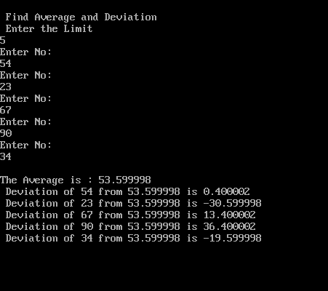

1. **WAP to find Biggest of all numbers in list**

**Program** **Output Screen**

void biggest(int a[],int);

void main(){

int nos[100],n,i;

clrscr();

printf("\n Find Biggest Number in a list\n Enter the Size\n");

scanf("%d",&n);

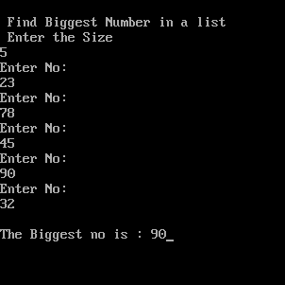 for(i=0;i<n;i++)

{

printf("Enter No:\n");

scanf("%d",&nos[i]);

}

biggest(nos,n);

getch();

}

void biggest(int a[],int n){

int i,big=a[0];

for(i=0;i<n;i++){

if(a[i]>big)

big=a[i];

}

printf("\nThe Biggest no is : %d",big);

}

1. **WAP to Arrange in ascending order of all numbers in list**

**Program**

void ascend(int a[],int);

void main(){

int nos[100],n,i; clrscr();

printf("\n Arrange in Ascending order in a list\n Enter the Size\n");

scanf("%d",&n);

for(i=0;i<n;i++) {

printf("Enter No:\n");

scanf("%d",&nos[i]);

}

ascend(nos,n); getch();

}

void ascend(int a[],int n){

int i,j;

for(i=0;i<n-1;i++){

for(j=i+1;j<n;j++){

if(a[i]>a[j]){

a[j]+=a[i];

a[i]=a[j]-a[i];

a[j]-=a[i];

}

}

}

for(i=0;i<n;i++)

printf("\t %d",a[i]);

}

**Output Screen**

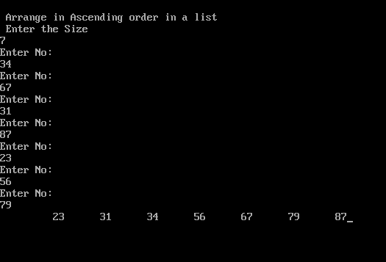

1. **WAP to Count the number of vowels in list**

**Program** **Output Screen**

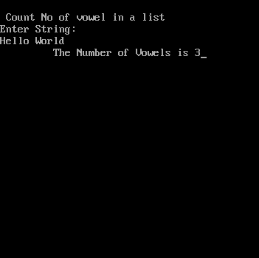#include<string.h>

void v_count(char a[],int);

void main(){

int n,i;char list[100];

clrscr();

printf("\n Count No of vowel

in a list\n");

printf("Enter String:\n");

gets(list);

n=strlen(list);

v_count(list,n);

getch();

}

void v_count(char list[],int n){

int i,count=0;

for(i=0;i<n;i++){

list[i]=toupper(list[i]);

if(list[i]=='A'||list[i]=='I'||list[i]=='E'||list[i]=='O'||list[i]=='U'){

count++;

}

}

printf("\t The Number of Vowels is %d",count);

}

1. **WAP Total the Elements in an array**

**Program** **Output Screen**

void total_elements(int a[10][10],int,int);

void main(){

int r,c,i,list[10][10];

clrscr();

printf("\n Total the ele\nEnter The Number of Rows");

scanf("%d",&r);

printf("Enter No of Columns:\n");

scanf("%d",&c);

total_elements(list,r,c);

getch();

}

void total_elements(int list[10][10],int r,int c){

int i,j,total=0;

//printf("\nEnter Elements");

for(i=0;i<r;i++){

for(j=0;j<c;j++){

printf("\nEnter Element:");

scanf("%d",&list[i][j]);

total+=list[i][j];

}

}

printf("\t The Total of all elements is %d",total);

}

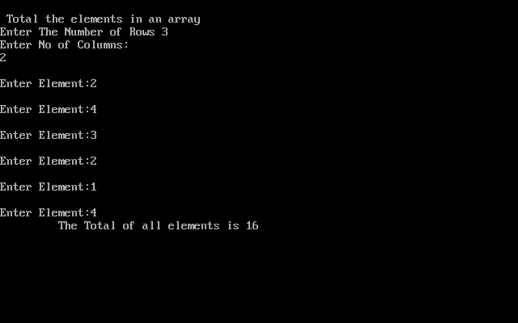

1. **WAP to fill the screen with 'A' using memory address**

**Program** **Output Screen**

void main(){

int i;

char far *v=0xB8000000;

clrscr();

for(i=0;i<=3999;i+=2)

*(v+i)=65;

*(v+2)=66;

for(i=1;i<=3999;i+=2)

*(v+i)=10000;

getch();

}

1. **WAP to store Students Record and display them**

**Program** **Output Screen**

struct dob{

int date,year;

char month[3];

};

struct student{

int rollno;

char name[20];

char add[20];

char department[20];

struct dob d;

};

void display(struct student s[100], int i);

void main(){

struct student s[100];int c,i=0;

do{

clrscr();

printf("\n\tStudent Records System\n");

printf("Enter Student Information\n");

printf("Enter Student's Roll No: \n");

scanf("%d",&s[i].rollno);

printf("Enter Student's Name: \n");

scanf("%s",s[i].name);

printf("Enter Student's Address\n");

scanf("%s",s[i].add);

printf("Enter Student's Department\n");

scanf("%s",s[i].department);

printf("Enter Student's Date of Birth:\nPress any key to start input\n");

getch();

printf("Enter the Date: \n");

scanf("%d",&s[i].d.date);

printf("Enter the First Three Letters of the Month: \n");

scanf("%s",s[i].d.month);

printf("Enter the Year\n");

scanf("%d",&s[i].d.year);

clrscr();

printf("\n\nDo You want to continue?\nPress 1 to Continue\nPress 0 to exit.");

scanf("%d",&c);

i++;

}

while(c!=0);

display(s,i);

getch();

}

void display(struct student s[100],int i){

int c,n=i;

printf("\n\n\t Displaying Students Information");

printf("\n\nRoll No\t\tName \t\tAddress\t\tDepartment\tDate of Birth \n--------------------------------------------------\n");

for(c=0;c<n;c++){

printf("\n%d\t\t%s\t\t%s\t\t%s\t\t%d-%s-%d\n",s[c].rollno,s[c].name,s[c].add,s[c].department,s[c].d.date,s[c].d.month,s[c].d.year);

}

}

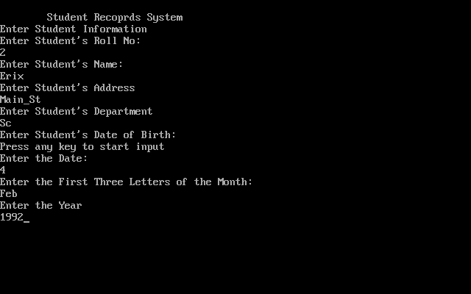

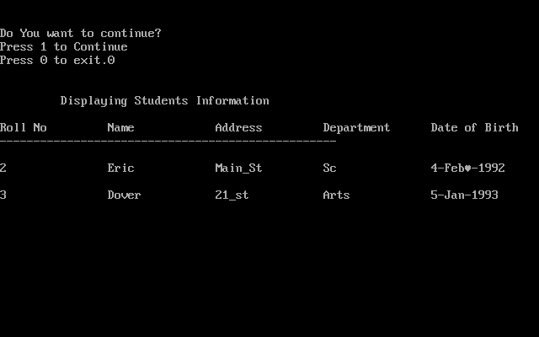

1. **WAP to Total the Elements in a row of a 2d array**

**Program**

void total_elements_row(int a[10][10],int,int);

void main(){

int r,c,i,list[10][10];

clrscr();

printf("\n Total the elements of array in a row\nEnter The Number of Rows\n");

scanf("%d",&r);

printf("Enter No of Columns:\n");

scanf("%d",&c);

total_elements_row(list,r,c);

getch();

}

void total_elements_row(int list[10][10],int r,int c){

int i,j,total[10];

//printf("\nEnter Elements");

for(i=0;i<r;i++){

total[i]=0;

for(j=0;j<c;j++){

printf("\nEnter Element:");

scanf("%d",&list[i][j]);

total[i]+=list[i][j];

}

}

printf("\t The Total of all elements in a row \n");

for(i=0;i<r;i++){

for(j=0;j<c;j++){

printf("\t %d",list[i][j]);

}

printf("\t=\t%d \n",total[i]);

}

}

**Output Screen**

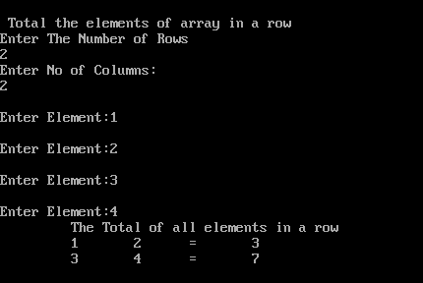

1. **WAP to Display Diagonal Elements of a 2d array**

**Program**

void disp_diag(int a[10][10],int,int);

void main(){

int r,c,i,list[10][10];

clrscr();

printf("\nTo Display the Elements in th eDiagonal\nEnter The Number of Rows\n");

scanf("%d",&r);

printf("Enter No of Columns:\n");

scanf("%d",&c);

disp_diag(list,r,c);

getch();

}

void disp_diag(int list[10][10],int r,int c){

int i,j;

//printf("\nEnter Elements");

for(i=0;i<r;i++){

for(j=0;j<c;j++){

printf("\nEnter Element:");

scanf("%d",&list[i][j]);

}

}

printf("\t The diagonal elements in the matrix \n");

for(i=0;i<r;i++){

for(j=0;j<c;j++){

if(i==j)

printf("\t %d",list[i][j]);

else

printf("\t");

}

printf("\n");

}

}

**Output Screen**

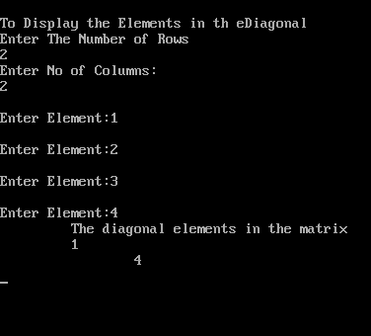

1. **WAP to Find LCM and GCD**

**Program** **Output Screen**

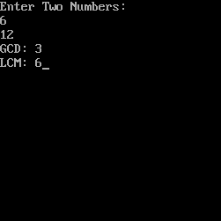void main(){

int n,n1,t,t1,i,b,hcf,lcm;

clrscr();

printf("Enter Two Numbers:");

scanf("%d %d",&n,&n1);

t=n;t1=n1;

if(n>n1)

b=n;

else

b=n1;

hcf=1;

for(i=2;i<b;i++){

if((n%i==0) && (n1%i==0)){

hcf=i;

n=n/i;

n1=n1/i;

}

}

printf("GCD: %d",hcf);

//LCM

lcm=hcf*n*n1;

printf("\nLCM: %d",lcm);

getch();

}

1. **WAP to Write a string to a file and count the number of vowels in the file**

**Program** **Output Screen**

void main(){

FILE *fp;

char c[100], s[100];

int count=0,len,i; clrscr();

fp=fopen("Z:\\File.txt","w+");

if(fp==NULL)

printf("File !Exist");

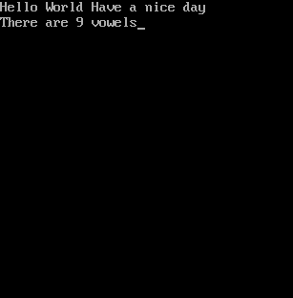 gets(s);

printf("\ns= %s",s);

fputs(s,fp);

len=strlen(s);

rewind(fp);

fgets(c,len+1,fp);

len=strlen(c);

for(i=0;i<len;i++){

switch(tolower(c[i])){

case 'a': case 'e':

case 'i': case 'o':

case 'u':

count++;

break;

} }

printf("There are %d vowels",count);

getch();

}

1. **WAP to write a Character to a file and read the character from the file**

**Program** **Output Screen**

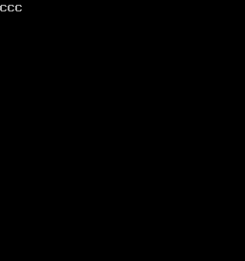void main(){

FILE *fs;

char c='c';

clrscr();

//Writing to File

fs=fopen("Z:\\C\\Files1.txt","a+");

if(fs==NULL)

{

printf("File does not Exist\n");

}

fputc(c,fs);

fclose(fs);

//Reading The File

fopen("Z:\\C\\Files1.txt","r");

while(!feof(fs)){

printf("%c",fgetc(fs));

}

fclose(fs);

getch();

}

1. **WAP to write a string to a file and read from it using fread() and fwrite()**

**Program** **Output Screen**

void main(){

char r[50];

char s[10];

FILE *fs;

clrscr();

fs=fopen("Z:\\fread_test.txt","w+");

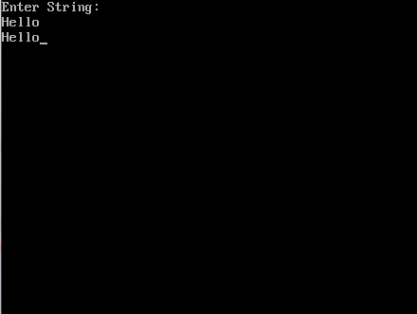 printf("Enter String:\n");

gets(s);

fwrite(s,sizeof(s),1,fs);

fseek(fs,0,SEEK_SET);

fread(r,sizeof(r),1,fs);

printf("%s",r);

getch();

}

1. **WAP to write to a file and copy its content to another file using Low level I/O operations**

**Program**

#include<fcntl.h>

#include<types.h>

#include<stat.h>

#include<stdio.h>

void main(){

int inhandle,outhandle,bytes;

char source[128],target[128];

char buffer[512],b[512]="";

clrscr();

printf("\nEnter the Source(Path and filename)\n");

gets(source);

outhandle=open(source,O_CREAT|O_TEXT|O_RDWR,S_IWRITE|S_IREAD);

if(outhandle==-1)

{

printf("\nSource file not created");

getch();

exit(0);

}

printf("\nEnter Content to Source file.");

gets(b);

write(outhandle,b,512);

fflush(stdin);

close(outhandle);

printf("\nEnter the Target(Path and filename)\n");

gets(target);

outhandle=open(source,O_TEXT|O_RDWR);

inhandle=open(target,O_APPEND|O_TEXT|O_RDWR);

while(1){

bytes=read(outhandle,buffer,512);

if(bytes>0){

write(inhandle,buffer,bytes);

}

else{

printf("Copy Success.");

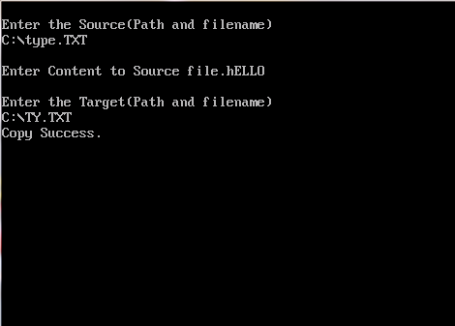 break;

} } getch();}**Output Screen**

1. **WAP MENU DRIVEN to perform addition, subtraction and multiplication on 2d matrices.**

**Program**

void add_arr(int a[10][10],int b[10][10],int,int);

void disp(int a[10][10],int,int);

void input(int a[10][10],int,int);

void sub_arr(int a[10][10],int b[10][10],int,int);

void mul_mat();

void main(){

int r,c,ch,i,list[10][10],list2[10][10];

do{

clrscr();

printf("\n\t\tMENU\n");

printf("\n1.Add two Matirces.");

printf("\n2.Subtract two Matirces.");

printf("\n3.Multiply two Matirces.");

printf("\n4. Exit.");

scanf("%d",&ch);

if(ch<3 && ch>0){

printf("\n\nEnter The Number of Rows\n");

scanf("%d",&r);

printf("Enter No of Columns:\n");

scanf("%d",&c);

input(list,r,c);

input(list2,r,c);

}

if(ch==1)

add_arr(list,list2,r,c);

else if(ch==2)

sub_arr(list,list2,r,c);

else if(ch==3)

mul_mat();

else if(ch==4)

exit(1);

else

printf("Wrong Input.");

}while(ch!=4);

getch();

}

void input(int list[10][10],int r,int c){

int i,j;

printf("\nInput Into Array");

for(i=0;i<r;i++){

for(j=0;j<c;j++){

printf("\nEnter Element:");

scanf("%d",&list[i][j]);

}

}

}

void add_arr(int list[10][10],int list2[10][10],int r,int c){

int i,j,sum[10][10];

printf("\nAdding the Arrays\n");

for(i=0;i<r;i++)

for(j=0;j<c;j++)

sum[i][j]=0;

for(i=0;i<r;i++)

for(j=0;j<c;j++)

sum[i][j]=list[i][j]+list2[i][j];

disp(sum,r,c);

}

void sub_arr(int list[10][10],int list2[10][10],int r,int c){

int i,j,diff[10][10];

printf("\nSubtracting the Arrays\n");

for(i=0;i<r;i++)

for(j=0;j<c;j++)

diff[i][j]=0;

for(i=0;i<r;i++)

for(j=0;j<c;j++)

diff[i][j]=list[i][j]-list2[i][j];

disp(diff,r,c);

}

void mul_mat(){

int a[10][10],b[10][10],m[10][10],i,j,k,c1,c2,r1,r2;

clrscr();

printf("Enter rows and Columns.");

scanf("%d %d",&r1,&c1);

printf("Enter rows and Columns.");

scanf("%d %d",&r2,&c2);

if(r2==c1){

for(i=0;i<r1;i++){

for(j=0;j<c1;j++){

printf("Enter Element [%d][%d]",i,j);

scanf("%d",&a[i][j]);

}

}

for(i=0;i<r2;i++){

for(j=0;j<c2;j++){

printf("Enter 2nd Element [%d][%d]",i,j);

scanf("%d",&b[i][j]);

}

}

for(i=0;i<r1;i++)

for(j=0;j<c2;j++)

m[i][j]=0;

for(i=0;i<r1;i++)

for(j=0;j<c2;j++)

for(k=0;k<c2;k++)

m[i][j]+=a[i][k]*b[k][j];

for(i=0;i<r1;i++){

for(j=0;j<c2;j++)

printf("\t%d",m[i][j]);

printf("\n");

}

}

getch();

}

void disp(int list[10][10],int r,int c){

int i,j;

printf("\nDisplaying Array\n");

for(i=0;i<r;i++){

for(j=0;j<c;j++)

printf("\t %d ",list[i][j]);

printf("\n");

}

}

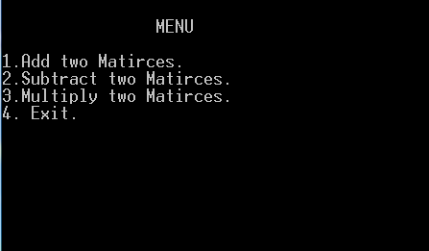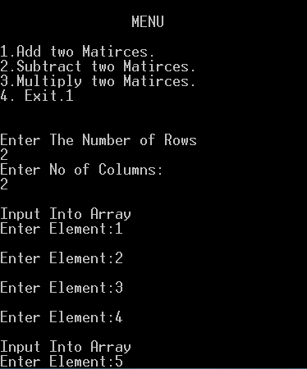**Output Screens**

Output Screen

Output Screen 1

Output Screen 3 Addition of 2 Matrices

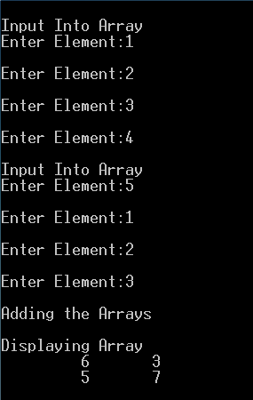

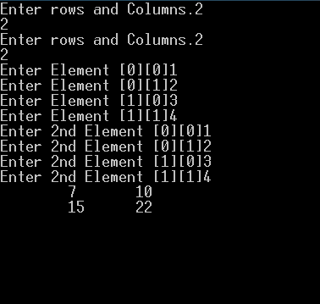

Output Screen 4: Multiplication of 2 Matrices

1. **WAP to display the complement of a matrix i.e if input is 1 change to 0 and vice versa.**

**Program**

void comp(int a[10][10],int,int);

void disp(int a[10][10],int,int);

void input(int a[10][10],int,int);

void main(){

int r,c,i,list[10][10]; clrscr();

printf("\n2D Array Program\nEnter The Number of Rows\n");

scanf("%d",&r);

printf("Enter No of Columns:\n");

scanf("%d",&c);

input(list,r,c);

comp(list,r,c);

}

void input(int list[10][10],int r,int c){

int i,j,t;

printf("\nInput Into Matrix \n Enter 0 or 1\n");

for(i=0;i<r;i++)

for(j=0;j<c;j++){

printf("\nEnter [%d][%d]",i,j);

scanf("%d",&t);

if(t==0)

list[i][j]=t;

else

list[i][j]=1;

}

}

void comp(int list[10][10],int r,int c){

int i,j;

printf("\nDisplaying Complement of the Matrix\n");

for(i=0;i<r;i++){

for(j=0;j<c;j++){

if(list[i][j]==0)

printf("\t 1 ");

else

printf("\t 0 ");

}

printf("\n"); }

}

**Output Screen**

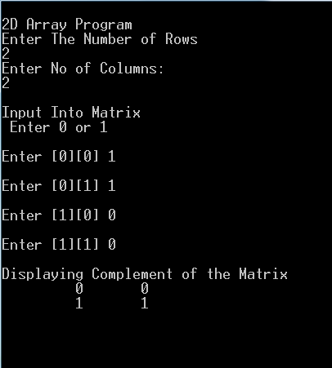

1. **WAP MENU DRIVEN to add records of an employee[name,age,salary,city] and display them.**

**Program**

struct emp{

int id,age;

char name[100],city[100];

char salary[20];

}emp1[50];

void main(){

int i=0,j,ch;

do{

clrscr();

printf("\n\n\t\tMENU\n");

printf("\n\t1.Add Records.");

printf("\n\t2.Display Records");

printf("\n\t3.Exit\n\t");

scanf("%d",&ch);

switch(ch){

case 1:

printf("\nEnter Employee id: ");

scanf("%d",&emp1[i].id);

printf("\nEnter Employee Name: ");

scanf("%s",emp1[i].name);

printf("\nEnter Employee Age: ");

scanf("%d",&emp1[i].age);

printf("\nEnter Employee City: ");

scanf("%s",emp1[i].city);

printf("\nEnter Employee salary: ");

scanf("%s",emp1[i].salary);

i++;

break;

case 2:

printf("\n \tEmployee Details: ");

printf("\n\tid\tName\tAge\tCity\tSalary\n\n");

for(j=0;j<i;j++){ printf("\n\t%d\t%s\t%d\t%s\t%s",emp1[j].id,emp1[j].name,emp1[j].age,emp1[j].city,emp1[j].salary);

}

getch();

break;

case 3:

printf("\nPress any key to exit");

break;

default:

printf("Re-enter your Choice.");

}

}while(ch!=3);

getch();

}

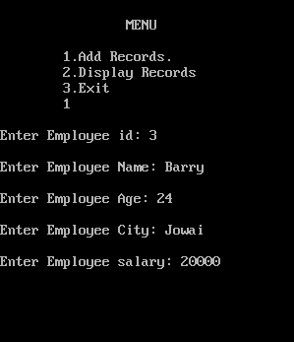**Output Screen**

Output Screen 1

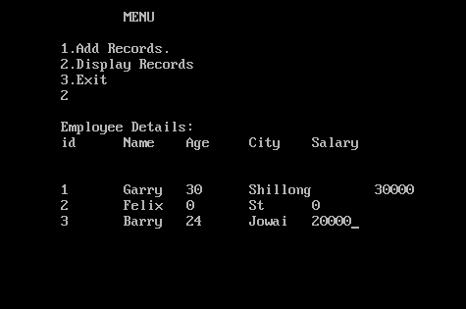

Output Screen

1. **WAP to insert a string to "TEST1.txt" and "TEST2.txt" and copy their content to "FINAL.txt", also count the number of words in "FINAL.txt".**

**Program**

void main(){

char s1[100], s2[100];

char s3[100],c,c2;

FILE *f1,*f2,*fn;

int len,count;

count=1;

f1=fopen("Z:\\test1.txt","w");

f2=fopen("Z:\\test2.txt","w");

fn=fopen("Z:\\final.txt","w+");

clrscr();

if(f1==NULL && f2==NULL)

printf("Cannot open file");

printf("Enter a sentence for test1.txt\n");

gets(s1);

printf("Enter a sentence for test2.txt\n");

gets(s2);

fputs(s1,f1);

fputs(s2,f2);

if(fn==NULL)

printf("Cannot Open file");

fclose(f1);

fclose(f2);

f1=fopen("Z:\\test1.txt","r");

f2=fopen("Z:\\test2.txt","r");

len=strlen(s1);

printf("\nCopying from test1.txt to final.txt\n");

fgets(s3,len+1,f1);

fputs(s3,fn);

printf("\nContents in test1.txt\n%s",s3);

len=strlen(s2);

c=0;

printf("\nCopying from test2.txt to final.txt\n");

fputc(' ',fn);

fgets(s3,len+1,f2);

fputs(s3,fn);

printf("\nContents in test2.txt \n%s",s3);

fclose(fn);

fn=fopen("Z:\\final.txt","r");

c=0;

while(c!=EOF){

c=fgetc(fn);

switch(c){

case ' ':

count++;

}

}

printf("\n\nThe Number of words in final.txt is %d",count);

getch();

}

**Output Screen**

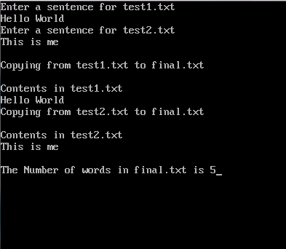

1. **WAP to create a formatted file to store a list of books and allow user to view any book by id. (Book: id, Name, Author...)**

**Program**

struct book{

int id ;

char name[20],author[20],publisher[20];

int quantity,edition;

};

void main(){

struct book s[50];

int i,n,id;

FILE *fp;

fp=fopen("Z:\\Books.Txt","w+");

clrscr();

printf("Book Information System\nEnter the number of entries you want :\n");

scanf("%d",&n);

for(i=0;i<n;i++){

printf("Enter the ID number :\n");

scanf("%d",&s[i].id);

printf("Enter the name of the Book:\n");

scanf("%s",s[i].name);

printf("Enter the Author : \n");

scanf("%s",s[i].author);

printf("Enter the publisher of book :\n");

scanf("%s",s[i].publisher);

printf("Enter the quantity of book:\n");

scanf("%d",&s[i].quantity);

printf("Enter the edition of book :\n");

scanf("%d",&s[i].edition);

fwrite(s,sizeof(s),1,fp);

}

fseek(fp,0,SEEK_SET);

do{

printf("\nSearching for a book:\n Enter book id : else enter 0 to exit");

scanf("%d",&id);

printf("\n\nName\t ID\t Author \t Quantity\t Edition \t Publisher \n");

fread(&s,sizeof(s),1,fp);

for(i=0;i<n;i++) {

if(id==0)

break;

if(s[i].id==id) printf("%s\t%d\t%s\t\%d\t\t\%d\t\t%s\n",s[i].name,s[i].id,s[i].author,s[i].quantity,s[i].edition,s[i].publisher);

}

}

while(id!=0);

getch();

}

**Output Screen**

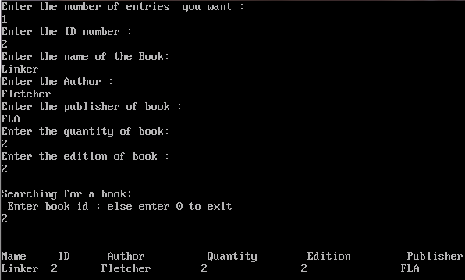

1. **WAP to simulate a basic calculator to perform four basic operations.**

**Program**

void plus(int, int);

void minus(int, int);

void div(int, int);

void mul(int, int);

void main(){

int n,m,c;

clrscr();

printf("\nBASIC CALCULATOR MENU\n");

printf("\nEnter two Numbers");

scanf("%d %d",&n,&m);

do{

printf("\n1.Add two numbers");

printf("\n2. Subtract two numbers");

printf("\n3. Divide two numbers ");

printf("\n4. Multiply two numbers");

printf("\n5. Exit");

printf("\nEnter Your Choice.");

scanf("%d",&c);

switch(c){

case 1:

plus(n,m); break;

case 2:

minus(n,m); break;

case 3:

div(n,m); break;

case 4:

mul(n,m); break;

case 5:

printf("Exiting"); getch(); exit(0);

default:

break;

}

clrscr();

}while(c<5);

}

void plus(int a,int b){

printf("\n Adding Two Numbers %d and %d",a,b);

printf("\nThe Sum is %d",a+b);

getch();

}

void minus(int a,int b){

printf("\n Subtracting Two Numbers %d and %d",a,b);

printf("\nThe Difference is %d",a-b);

getch();

}

void div(int a,int b){

printf("\n Dividing Two Numbers %d and %d",a,b);

if(a>b)

printf("\nThe quotient is %d",a/b);

else if(b>a)

printf("\nThe quotient is %d",b/a);

getch();

}

void mul(int a,int b){

printf("\n Multiplying Two Numbers %d and %d",a,b);

printf("\nThe Product is %d",a*b);

getch();

}

**Output Screen**

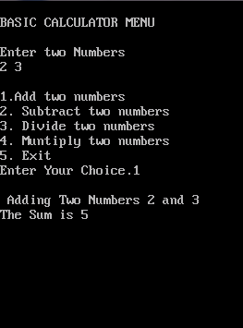

1. **Write a graphics program to draw concentric circles.**

**Program**

#include<graphics.h>

void main(){

int gd=DETECT,gm,n,i=10;

initgraph(&gd,&gm,"C:\\TC\\bgi");

printf("how many circles do you want?(Maximum 10)\n");

scanf("%d",&n);

if(n<=10){

n*=10;

while(i<=n){

circle(150,100,i+10);

i+=10;

}

}

getch();

}

**Output Screen**

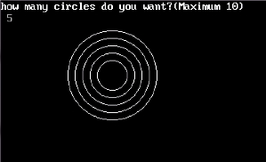

1. **Write a graphics program to fill screen with a grid of 50x50px.**

**Program** **Output Screen**

#include<graphics.h>

void main(){

int gd=DETECT,gm,mx,my;

int x=0,y=0;

initgraph(&gd,&gm,"C:\\TC\\bgi");

mx=getmaxx();

my=getmaxy();

setlinestyle(DOTTED_LINE,1,1);

while((x<=mx)&&(y<=my)) {

line(x,y,x,my);

x=x+50;

}

x=0;

while((x<=mx)&&(y<=my)){

line(x,y,mx,y);

y=y+50;

}

getch();

}

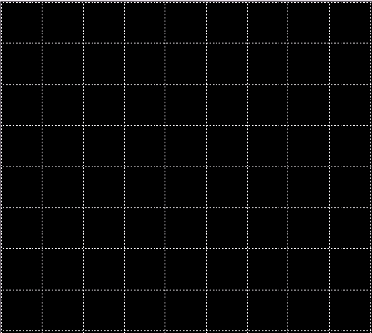**Output Screen**

1. **Write a graphics program to draw a triangle inside a circle.**

**Program**

#include<graphics.h>

void main(){

int gd=DETECT,gm;

int t[]={200,100,100,200,300,200,200,100};

initgraph(&gd,&gm,"C:\\TC\\bgi");

circle(200,200,100);

drawpoly(4,t);

getch();

}

1. **Write a graphics program to draw two ellipse intersecting one another.**

**Program**

#include<graphics.h>

void main(){

int gd=DETECT,gm;

initgraph(&gd,&gm,"C:\\TC\\bgi");

ellipse(100,100,0,360,50,10);

ellipse(100,100,0,360,10,50);

getch();

}

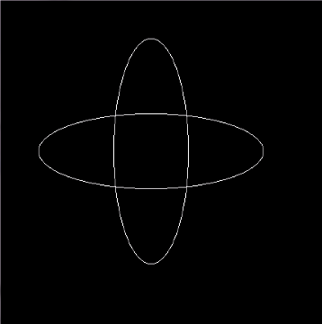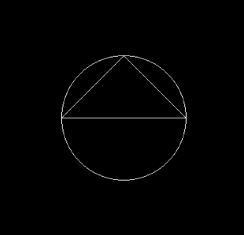**Output Screens**

Q50.Intersection of two Ellipse.

Q49. Triangle inside a circle.